Figure 1 - Key Words Spoken Aloud During the Play Through of Video 1

The data from this pie chart showcases that many found the video entertaining and a reflection of the medium it was just trying to convey. Nearly 50% of key words from participants was the word cool, which reiterates the cinematic/trailer feel they got when watching the piece. This cinematic feel is further invoked by the camera angles as Participant H stated, *“I liked the different camera angles as well, especially the cut to the security footage cam as well as the more adventurous ones like the ankle height one. Having a lot of different perspectives of the same scene helped liven it up”.* Furthermore, as shown in the chart, the word “perspective/s” is used a number of times to describe the scene, a key component of an action movie.

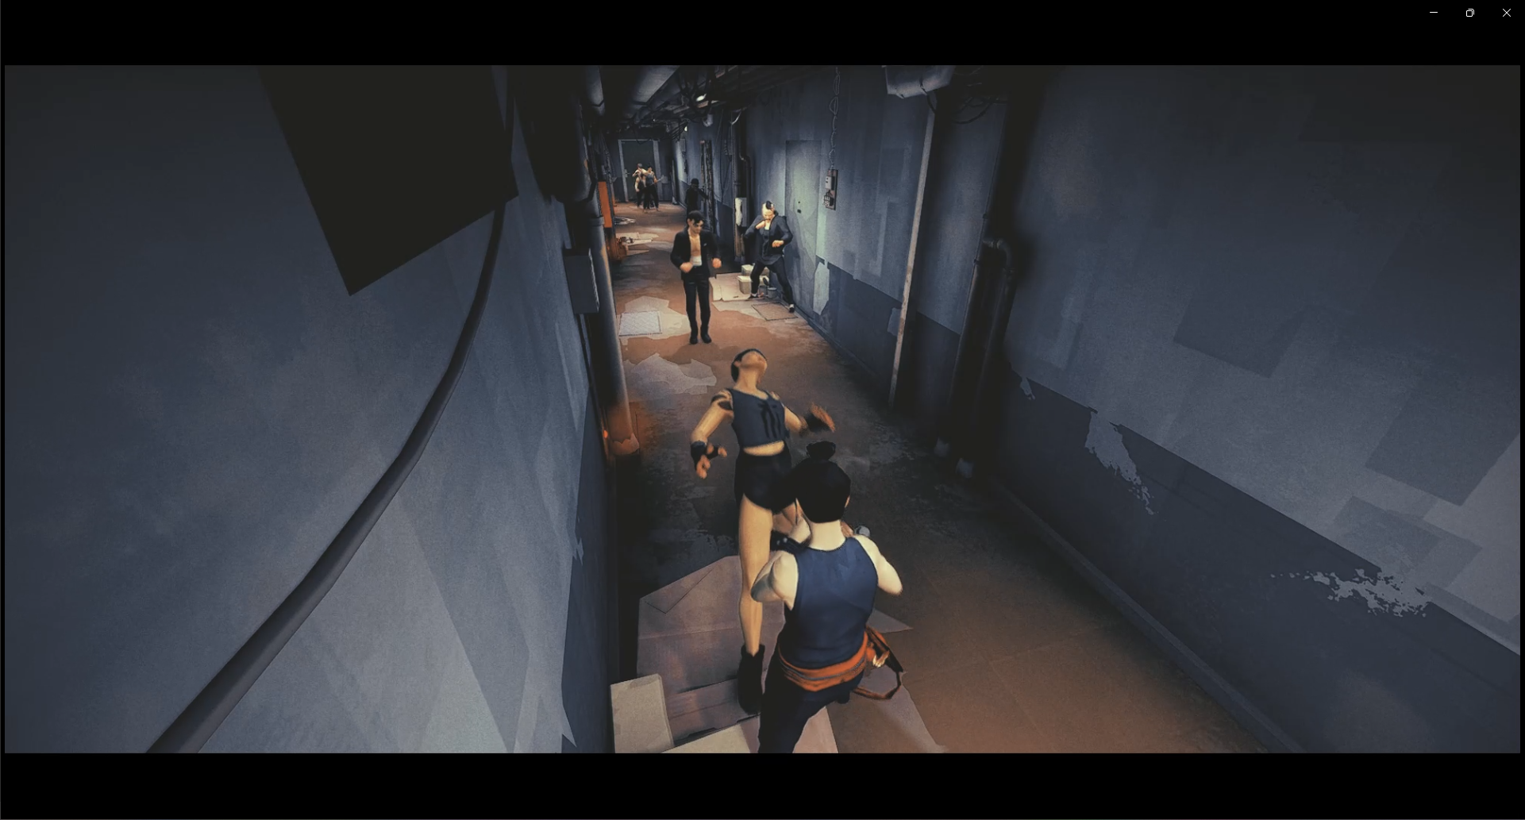

Figure 2 - Scene from Video 1

Figure 3 - Key Words Spoken Aloud During the Play Through of Video 2

During the viewing of Video 2, many participants found the video rather humorous due to the contrast in visuals and music, especially near the latter half of the video when a saxophone is introduced into the music. This *laughter* was a reflection of their confusion, as declared by Participant A, *“The slow kind of jazz bar feel understates what you’re watching… it is such a big contrast. However, I would say it feels more cinematic than the first one, but it is also funnier”. Participant* A wasn’t the only one to feel this way as stated by the focus group pertaining to Participant P and Q, *“I was entertained but entertained because it felt wrong, but also gangster like, close to a 1920s noir vibe”.* I believe video 2 successfully accomplished the noir genre and even gained a few *empathetic* feelings along the way, but the improvement as stated by many lies in the music being changed to fit the narrative of the clip.

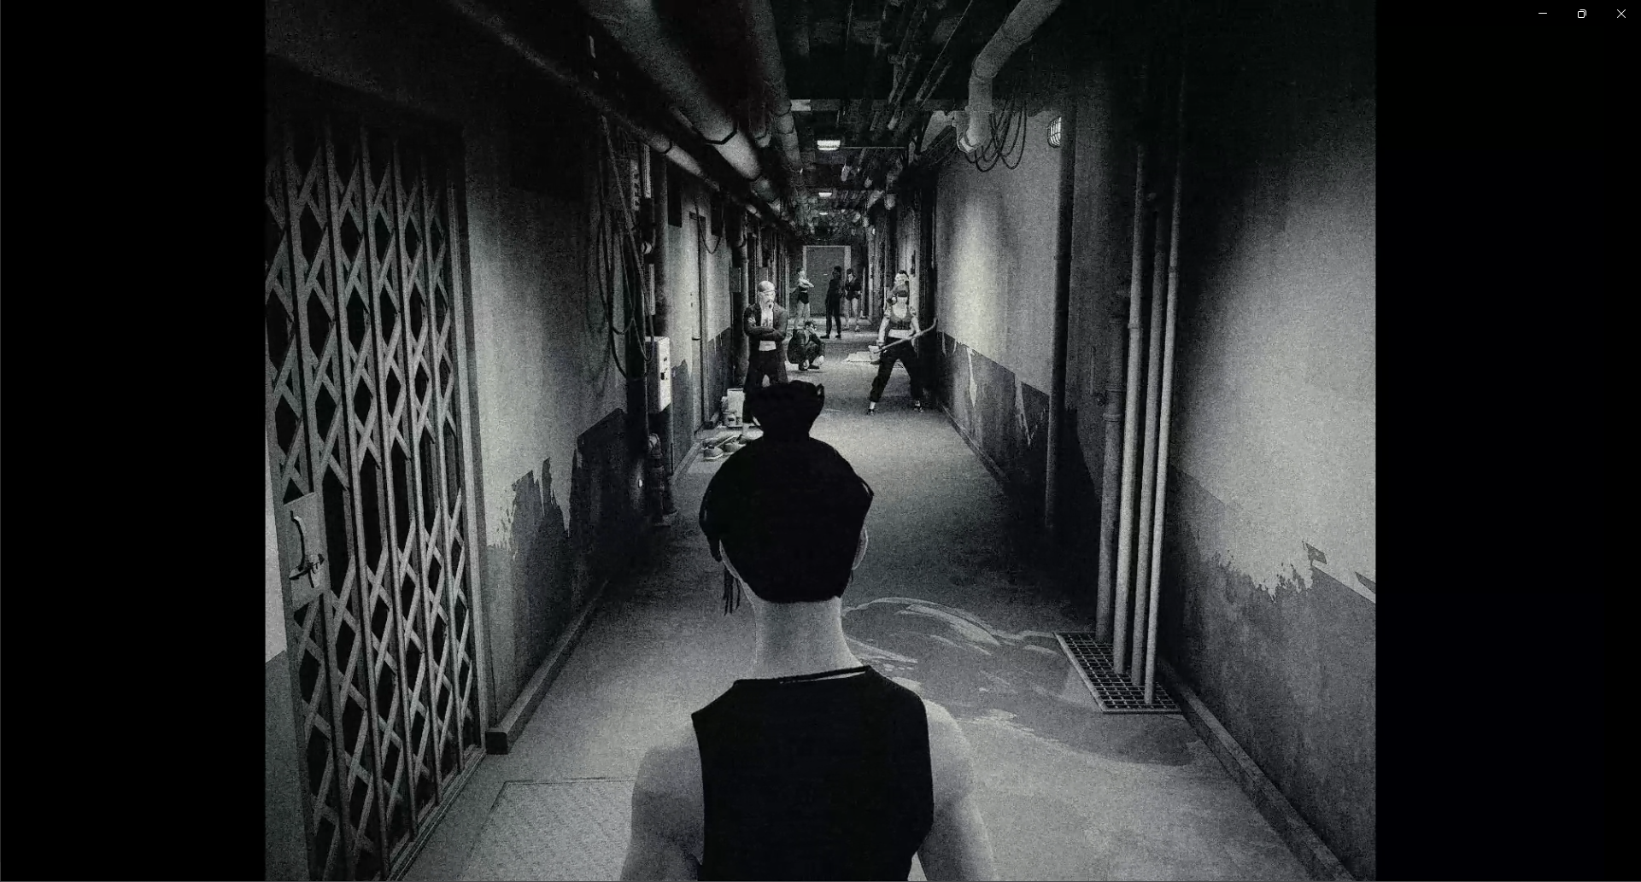

Figure - Scene from Video 2

Figure 5 - Key Words Spoken Aloud During the Play Through of Video 3

The most obvious takeaway from video 3 is the colour palette being a big contrast from the last two videos, being *bright* and *light-hearted*. This led to it being compared to various forms of media like dance, comedy and drama. *“It was a lot brighter, and the music didn’t interfere, it just made it more enjoyable”* a quote from Participant E, who like many enjoyed the clip but also did note the contrast in nature between the colourful scene and the visuals on screen. A reoccurring theme for this video was the colour making the scene appear less brutal than previous clips, as observed by Participant D, “*It didn’t feel as serious even though the action was still there. The lighting and the music made it rather jolly”.*

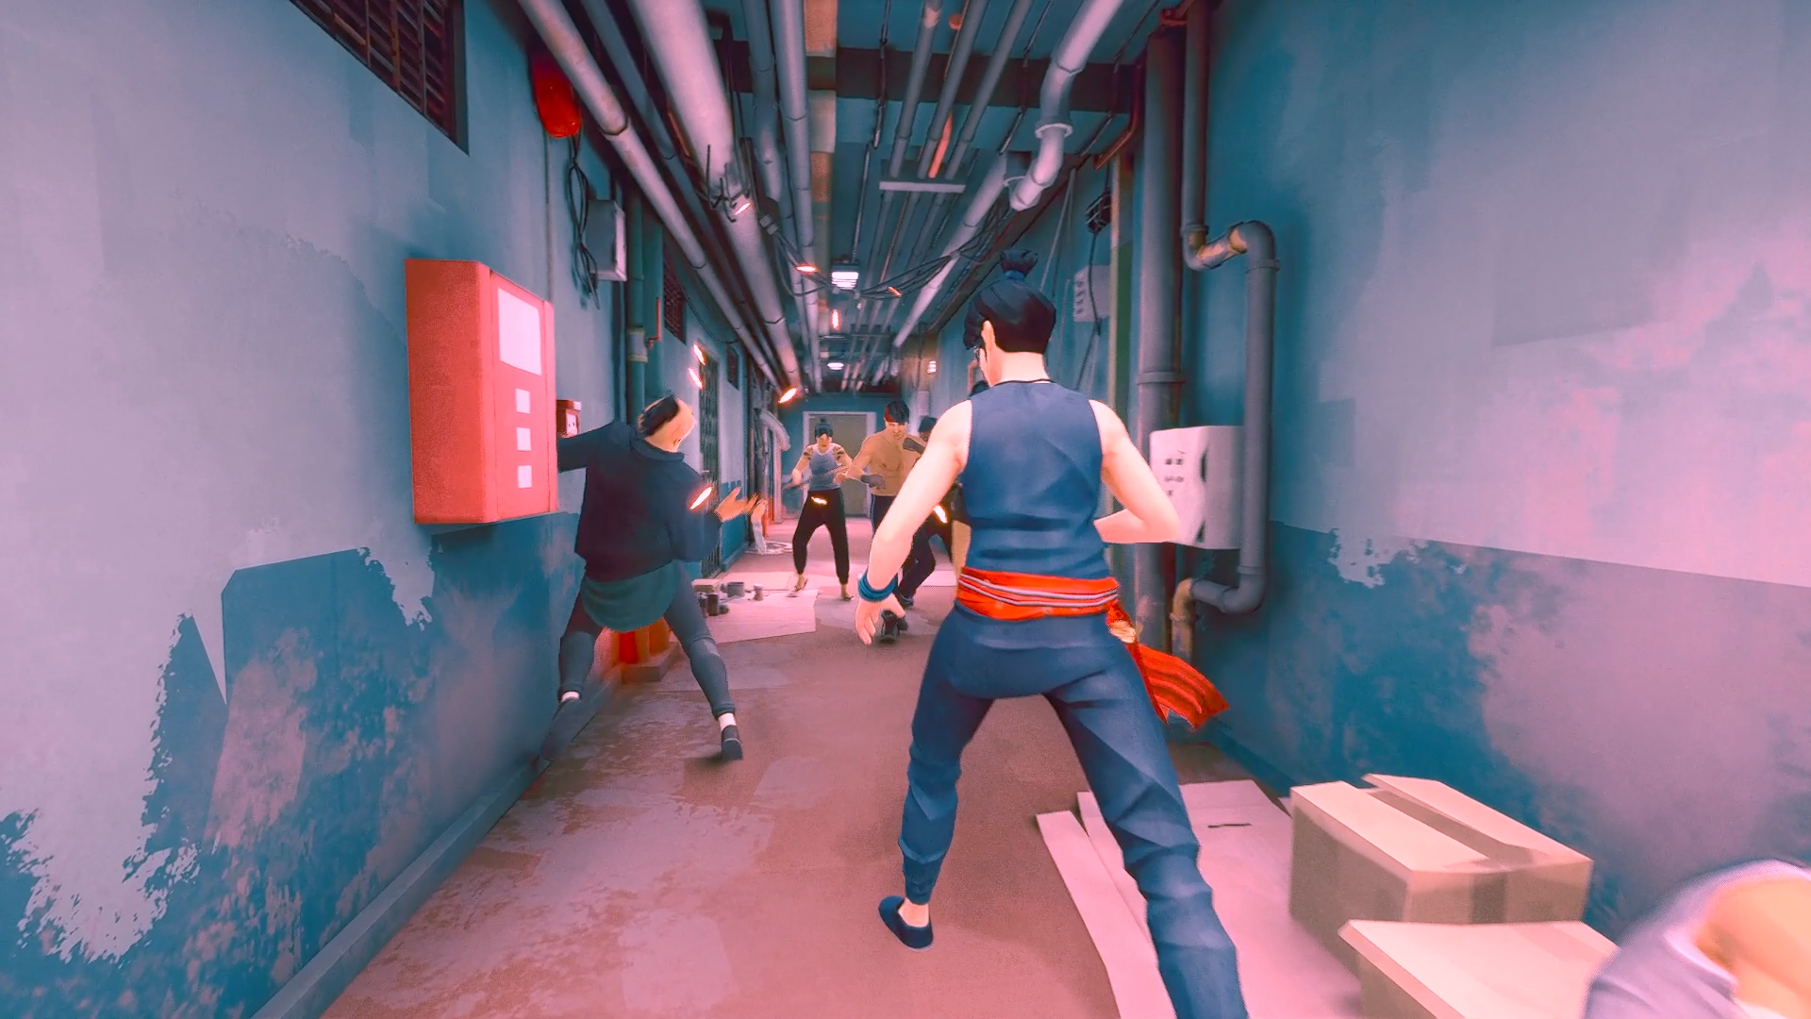

Figure 6 - Scene from Video 3

Figure 7 - Key Words Spoken Aloud During the Play Through of Video 4

As displayed in Figure 7, this video completed its intended goal of being a thriller due to the elements on screen as well as heard. One participant mentioned it looked like the *matrix*, this is due to the colour palette, as mentioned by Participant A, *“lots more blues and greens making it a bit colder and more colder emotionally”.* This when paired with the SFX and music made for a more “*threatening and more menacing*” scene. Participant C says, *“The heartbeat sound raised the stakes for me and made the scene feel more intense*”. This tense and high-stake feel is the fundamental element of thriller and what a creator aims to draw out of their audience.

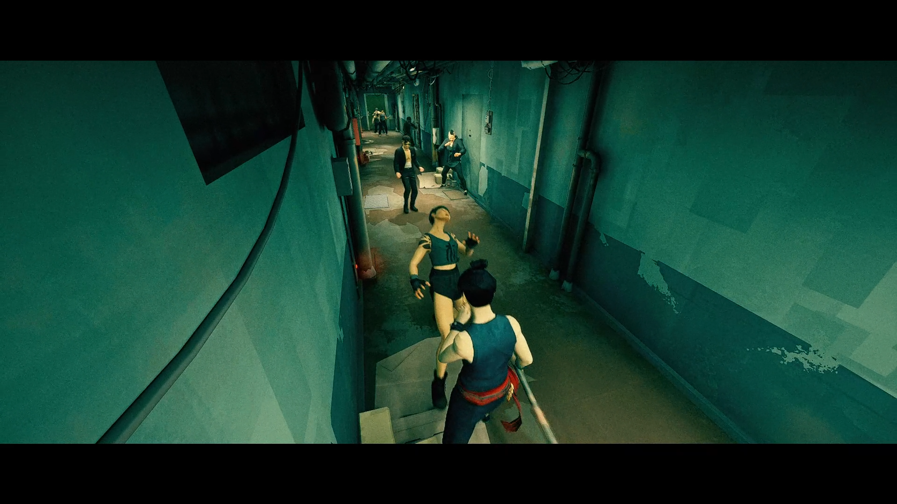

Figure 8 - Scene from Video 4

Figure 9 - Key Words Spoken Aloud During the Play Through of Video 5

Video 5 invoked a lot of thoughts and feelings during the interviews but also while watching. Users were visually and audibly confused at elements happening on the screen, but many came to a conclusion of *juxtaposition* which was used to demonstrate a dream state against reality. According to Participant F, “*I didn’t quite understand what I was watching, and I ended up getting caught trying to figure out what I was watching rather than watching*.” This was due to the jump between colour and greyscale as well as the music changing in accordance with the colour. While the *confusion* was very apparent as displayed in Figure 9, Participant C stated, *“it caught my interest, but I was still confused*”. Therefore, there is room for such a technique but as Participant H says, “*Keep it one tone or if you wanted to escalate it, do it gradually. If you wanted to go from greyscale to colour… leak in colour but keep the music consistent.”*

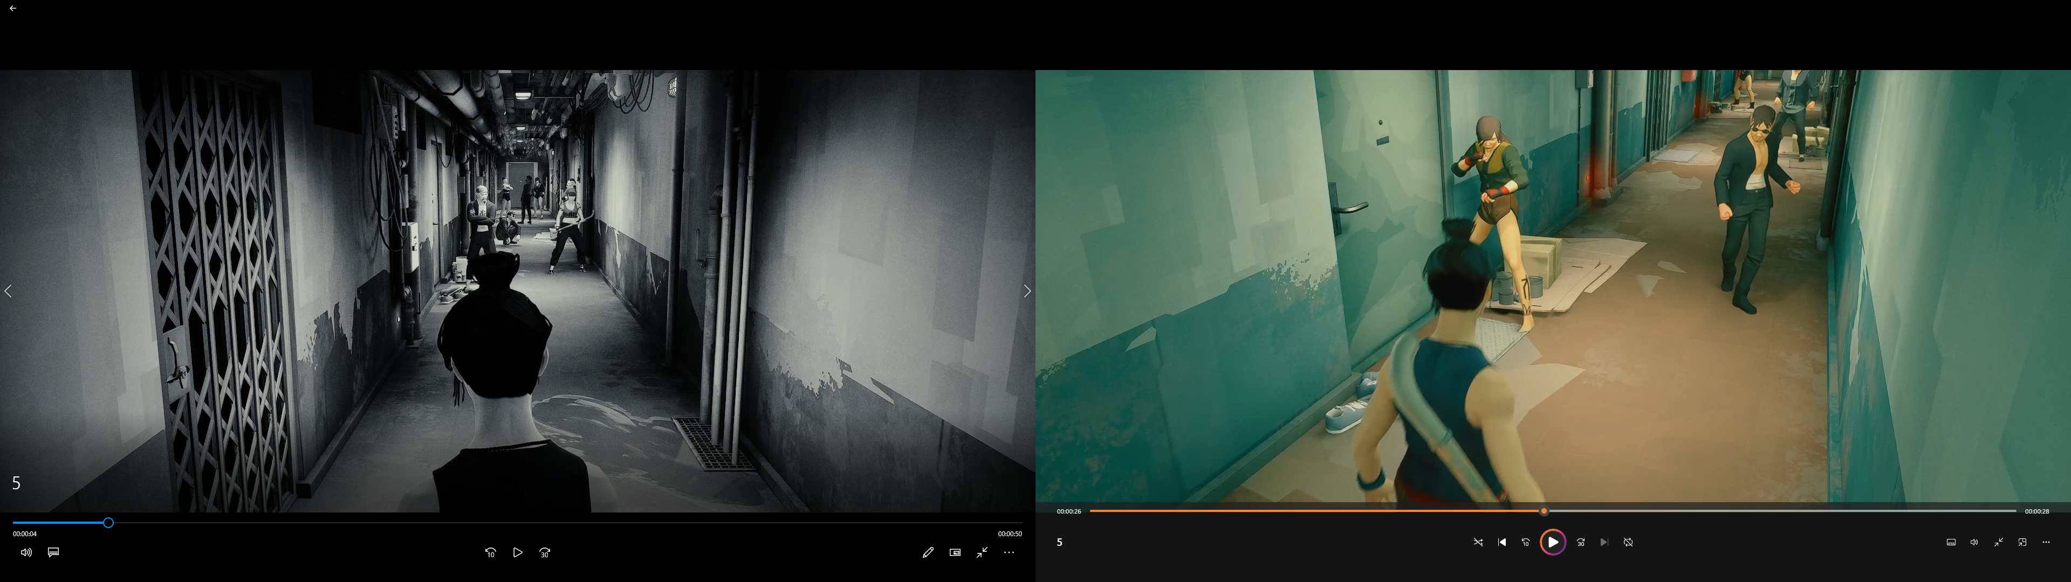

Figure 10 - Scenes from Video 5

Figure 11 - Key Words Spoken Aloud During the Play Through of Video 6

Many Participants while watching Video 6 were *confused* while viewing, however this video felt more grounded towards some. Participant L states, “*while watching I was confused but this felt like an execution of several different styles in one video”.* In which they would be correct in saying. Additionally, Participant F says, “*the inconsistent colour palette and music felt like a spy/heist/action movie*”. Therefore, while the video was confusing many Participants were able to pick up on the element queues display. This video demonstrates that you can cram a video with numerous elements of the same genre, but consistency is key in portraying a cohesive narrative.

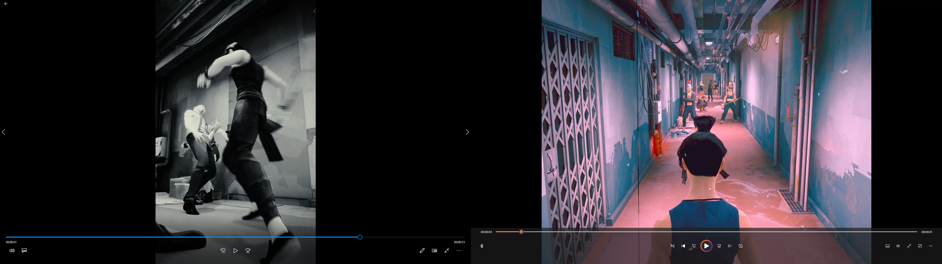

Figure 12 - Scenes from Video 6

Figure 13 - Key Words Spoken Aloud During the Play Through of Video 7

As displayed in Figure 13, Video 7 was a whirlwind of emotions, but it was almost unanimous that the video lacked *direction* which easily led to people being *lost.* Participant L says, “*for the first five seconds I enjoyed it but after that it didn’t feel like there was genre in mind*”. This was an intentional move as elements were put in place for subversion, as stated by Participant E, “*the wrong music with the wrong colour*”. Of my 15 participants approximately 25% of viewers enjoyed the video. This further reinforces my previous point of viewers needing a consistent genre during their time watching. This is made apparent from Participant D’s perspective, *“the past videos have been cohesive, that was quite hard to follow… the video had a bit of everything which made it harder to watch”.*

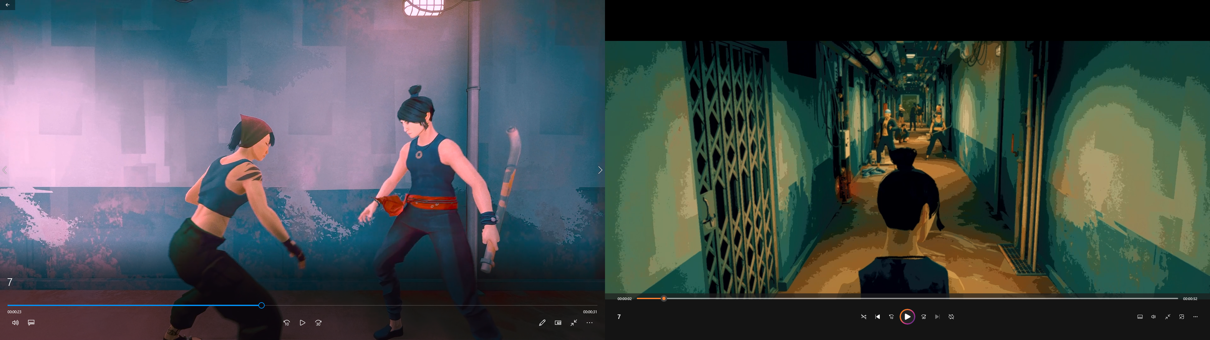

Figure 14 - Scenes from Video 7

Figure 15 - Key Words Spoken Aloud During the Play Through of Video 8

While watching Video 8, many Participants were quick to notice the *Lack of Music* which to many made the scene rather boring. Both Participant A and B when asked how they felt when watching the video stated, “*It felt like it was missing something*”, with Participant A to further state, “*if felt one dimensional as it missed a certain depth”.* This led to the main improvement of the video suggested by many to be adding music. Participant N says, “*some sort of music which blended well with the choreo*” would be suitable if the intention was to keep a low-profile scene. Similarly, Participant P stated, “*some sort of soundtrack, just subtle would be nice”.*

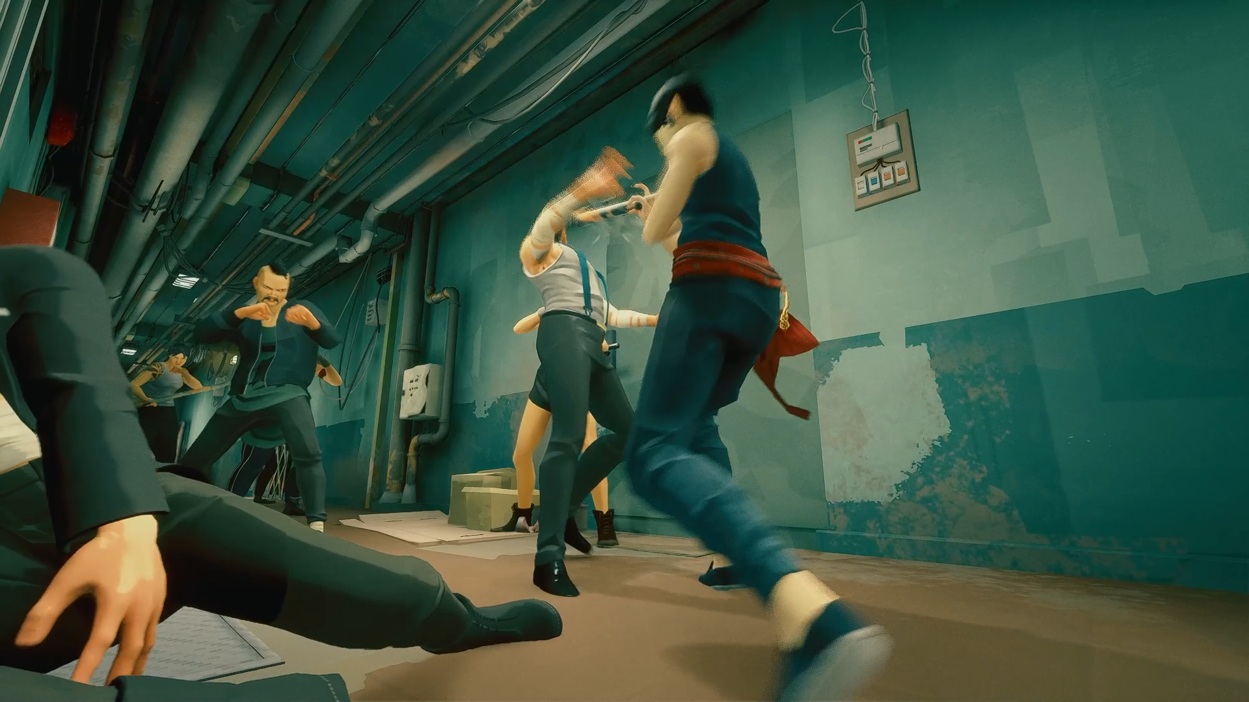

Figure 16 - Scene from Video 8